

Rosanna Cubs – Watsonia RSL
Tuesday 19th May

On Tuesday the 19th, we’re going to meet at Watsonia RSL to learn about “Their Service – Our Heritage” as part of earning the Heritage Badge.

Details:
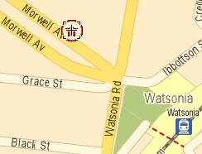
- Meet at 7pm at Watsonia RSL, 6 Morwell Ave, Watsonia (see map – there is car parking and it’s also a short walk from Watsonia Station).
- Pickup at approx 8pm from the RSL.
Cubs will be learning about the service of our Service men and women.
For those who attended Anzac Day Services, this will complete their Heritage Badge requirements. For others, this will cover half the badge and we can advise on the requirements for the rest.
Melway Ref: 20 E4

See you there – don’t miss it!

Regards

Akela
9434 7594
0411 121 495
akela@rosannacubs.org

See us at http://www.rosannacubs.org

